J Unit5 (lib)
What is test & why J unit?
- Unit test Is small piece of code check answer what you expected.
- Annology – “you baked cake receipe before selling it you test is it baked? Unit test is done by computer in mili second Everytime changed recepie. ”
- Without test you checked by programming and checking around. With test you press 1 button no whether everything still work .
- Every step follow there same step
- 1 arrange – set things up
- example : - Calculator calc = new Calculator();

- 2 act- do that thing
- int result = calc.add(2, 3);

- 3 assert – check the answer
- assertEquals(5, result);

What is Maven?
Maven is project management & build tool. it does 3 jobs like 1-download lib file(.jre), 2-its complie code you, 3- run your test by one command.
Annology – “(wirte you write recipe using java code) maven is your kitchen manager you hand over your shopping list (pom.xml) the manger buys it sets of kitchen cooks and tell you the dish failed test check”
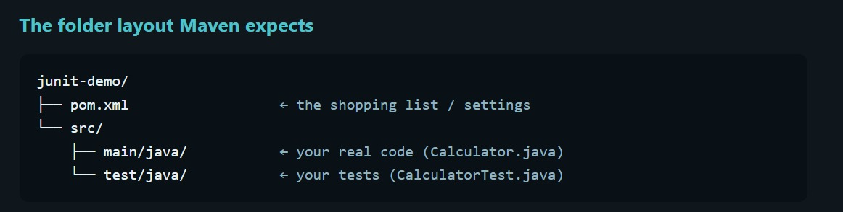
mvn - version
mvn compile – complie source main file
mvn test – complie everything
mvn clean test – delete old folder then test
steps for junit testing
- design understanding problem statement and solve pseudo code
- Write code
- write test
- run the test

Architecture of J Unit
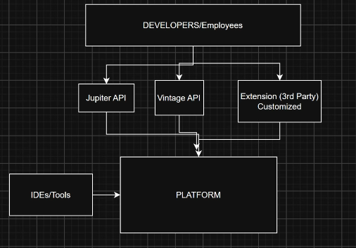
The engine route start test talks to IDE’s and maven define how test engine plugin
It used by vs code
Junit jupitor
The new programming model: @Test, @BeforeEach, assertions. Also contains the engine that runs Jupiter tests.
Junit vintage API
A compatability engine that runs old unit 3 & 4 test on the new platform. It is used by the old project that haven’t yet migrated.
Anology – Cinema “the J unit platform id building, projectors system and ticket counter & its can show you any movies. Jupitors is todays modern movies the only one you can write. vintage is an old movies that run on the same projector the building doesn’t care which movies played as long as matching engine (player exist).”
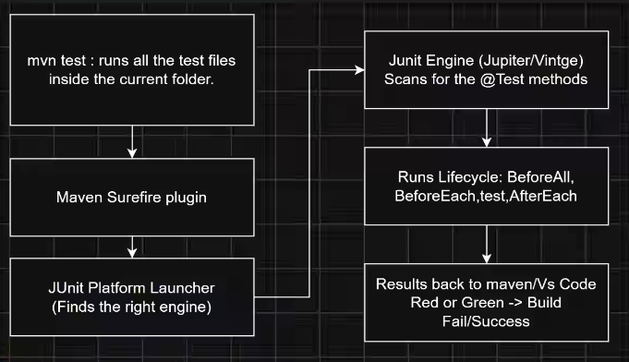
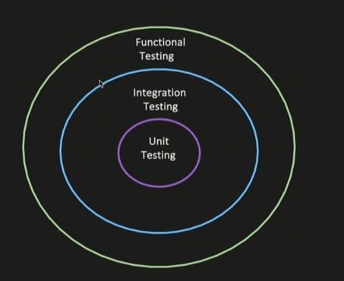
Type of testing
1 - Unit testing,test of indivisual testing unit or method
2- intregration testing – testing of an multiple modeules or component together to test if system behave properly when wried together goal is not to test end to end user behavior, it just if multiple module or system wired together thus intended behavior
Service > database
Flow should reach database layer you assert
Serive A > published to kapca – “successfully published kapca topic”

Function testing
Asseration Anotation?
Test life cycle
J unit 5 Architecture

